Infrastructure As Code
Every application runs inside an environment.
An environment is a stack of software and hardware components that supports the application.
- Building an environment involves many activities such as:
- Bringing up components.
- Provisioning and configuring components based on need.

IaC is an important DevOps important feature that enables you to define, automatically manage, and provision infrastructure through source code.
Infrastructure is managed like a software system.
IaC is frequently referred to as Programmable Infrastructure.

Why IaC?
- Everything required to run the services are connected, deployed and monitored together.
- Faster delivery of quality services
- Built-in automation.
- Changes can be made faster than manual.

What would happen if something fails on a server?
Traditionally,
- A support person from the IT team will physically reach the server and make the fix.
- Consumes workforce, which is a slower process.
In IaC,
- A tool will monitor the state of the infrastructure.
- A script will be sent automatically to fix the issue.
- Faster process, no/less human involvement.

Challenges Addressed by IaC
- Server Sprawl - Growth in the number of servers makes it difficult to manage.
- Configuration drift - Differences in version and configurations across servers.
- Snowflake Server - Requires special configuration and is different from other servers in the network.
- Fragile infrastructure - Infrastructure disrupted easily but is hard to fix.

IaC Principles
Principles you should keep in mind while designing your infrastructure
- Systems can be reproduced with fewer efforts
- Systems are replaceable
- Systems are consistent
- Processes are repeatable
- Ever evolving design

Infrastructure that can be defined as a code is broadly categorized as:
- Compute
- Databases, Caching, and Messaging
- Storage, Backup, and Content Delivery
- Networking
- Security and Identity
- Monitoring, Logging, and Analytics
- Management Tooling
IaC Implementation Approaches
Declarative
- Focuses on the desired end state of infrastructure (Functional).
- Tools perform the necessary actions to reach that state.
- Examples are Terraform, CloudFormation, and Puppet.
Imperative
- Focuses on how to achieve the desired state (Procedural).
- Examples are Chef, Ansible.

Declarative or Imperative?
Imperative model has the following issues over declarative:
- The state of the infrastructure is not fully captured, so you may need to know the order in which you applied the changes.
- You should remember the full history of changes that has ever happened to the infrastructure.
- The code bases tend to grow large and get complicated over time because of the inherent limitation of re-usability.
Mutable and Immutable
***Mutable Infrastructure***:
- When a change is required, the system in production is patched.
- Sometimes it might be confusing.
- Bigger differences between systems in production and development.

***Immutable Infrastructure***:
- When a change is required, it completely replaces the servers.
- It increases the predictability.
- Only a minor difference between the system in testing and system in production.

Disposability principle - ***Do not fix it, throw it away***.
Dynamic Infrastructure Platform
- Dynamic Infrastructure Platform (DIP) lets you create, destroy, replace, resize, and move the resources readily, which enhances disposability.
- Software must continue running even when servers are added, removed or resized.
Requirements
- ***On Demand***:
- The resources can be created or destroyed dynamically.
- Plan your budget to be growing on demand.

- ***Programmable***:
- The API must be scriptable.

- ***Self-service***:
- Increases the availability and performance.
Dynamic Infrastructure platform (DIP) resource offers three key blocks.
- ***Compute Resources***: Server instance that makes the server management task more convenient and powerful.
- ***Network Resources***: The platform should be able to enable connectivity between internal as well as external terminals.
- ***Storage Resources***: As your infrastructure is dynamic, your required storage too must be dynamic.
Choosing a platform, consider all these factors:
- Security and data protection
- Requirements for Variable capacity
- Legal Constraints on hosting locations
- Build Cost
- Commodity or differentiator
Before Picking a Cloud Provider:
- Supports various services
- Dependency Resolution - Downloading all the dependency related information from the master once a dependency is identified in the configuration file.
- Idempotency - The same configuration files should yield the same result every time it gets called
- Existing tool integration
- Platform agnostic templates
- Extendibility
Benefits of Server-less Configurations
- Auto-scale
- Pay-as-you-use
- Supports Micro services
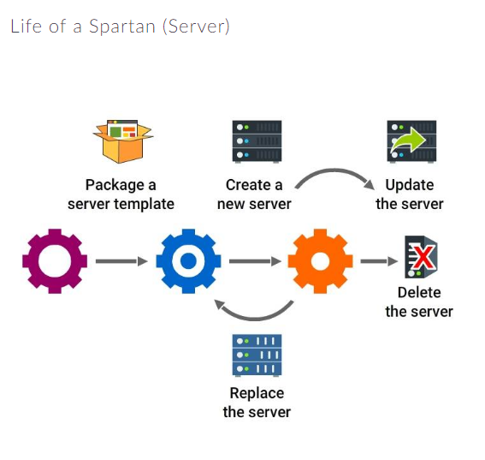
Tools
- Terraform
- An open source tool developed by HashiCorp
- Written in Go.
- Used to build, change and combine infrastructures safely and efficiently.
- Detects the state changes in an infrastructure and builds the *terraform plan*.

- CloudFormation
- Proprietary tool, developed by Amazon
- Supports all the AWS resources
- Easy to configure AWS resources through CloudFormation
- CloudFormation Designer tool may be used to generate the code designing the infrastructure by drag and drop option.

- OpenStack Heat
- Heat is an infrastructure definition tool developed by OpenStack.
- Its orchestration engine takes templates as a base and creates multiple composite cloud apps.
- Written in Python.
- Uses text files to define the templates.
- Supports many existing templates of CloudFormation tool.

- Chef
- A tool written in Ruby and Erlang to automate the configuration management tasks.
- Pure Ruby, DSL (Domain Specific Language) are the main ingredients of all her Recipes.
Chef - The actual definition
- Chef is a server configuration tool.
- You can write Recipes to describe your server applications and a group of Recipes makes a Cookbook.
- HP Public Cloud, Facebook and Prezi are using Chef for their automation.

